**18/03/2019**

**EE446 LABORATORY**

**EXPERIMENT 2**

**PRELIMINARY REPORT**

**Muttalip Caner TOL**

**2031466**

**Tuesday Afternoon**

**1.2.1. Datapath Design**

**3.** I have used Booth’s algorithm which is shown in Figure 1, in order to handle with the signed multiplication. Therefore, we should carry the Q [0] and Q [-1] bits as the control unit inputs from the Datapath.

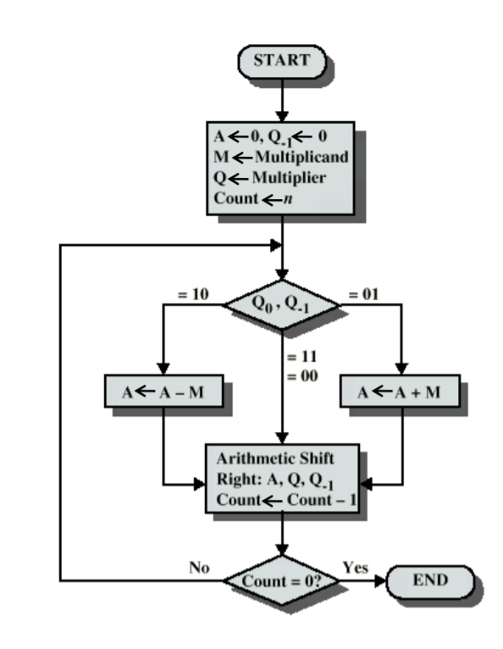

Figure 1. Booth's Signed Multiplication Algorithm

In Figure 1, A and Q are implemented as two shift register. Q-1 is another 1-bit register. “n” is the number of bits of the operands. At the end of the algoritm, A holds the most significant half byte and Q holds the least significant half byte of the result.

**4.** My signed division algorithm is as follows:

* If R1 is negative, take 2’s complement of R1
* If R0 is negative, take 2’s complement of R0
* Apply non-restoring division algorithm which is shown in Figure 2.
* Take 2’s complement of the Quotient if R0 and R1 have different signs at the beginning.
* Take 2’s complement of the Remainder if Dividend is negative at the beginning

Since we have used non-restoring division algorithm, we need to carry the sign bit of the A register to control unit.

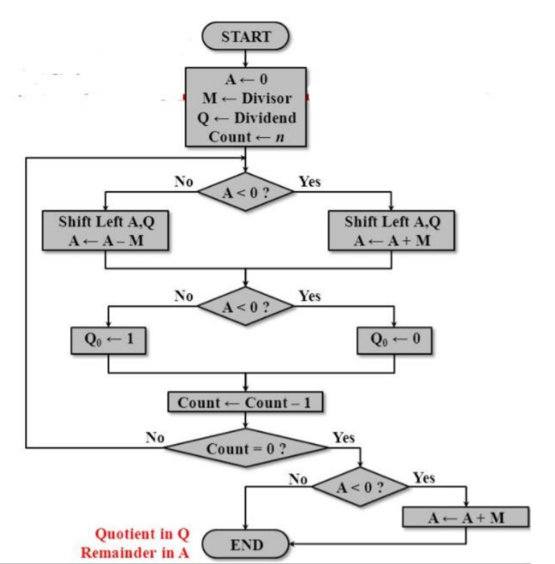

Figure 2. Non-restoring division algorithm

**1.2.2. Controller Design**

**1.** Figure 3 shows the controller unit.

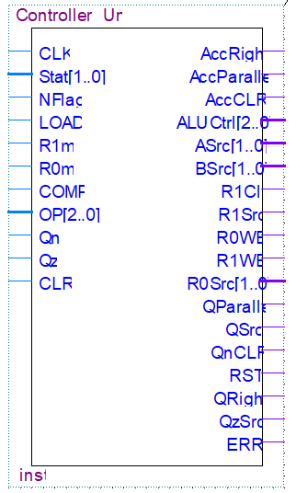

Figure 3. Controller Unit as a block box

**2.**

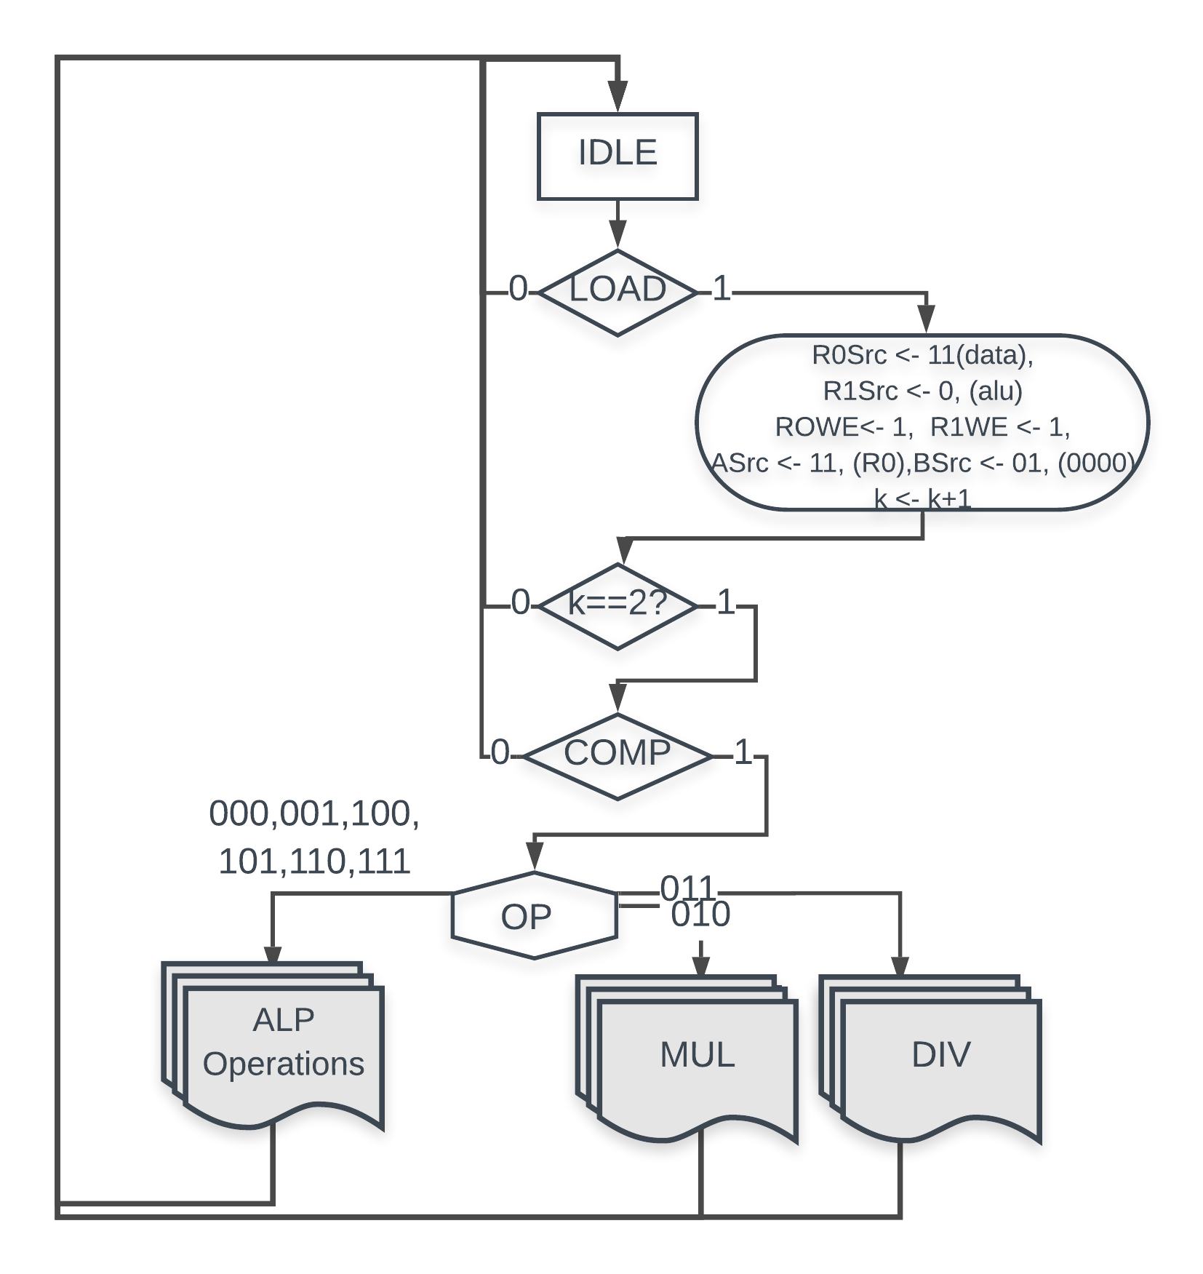

Figure 4. First black box

**s**

**3.**

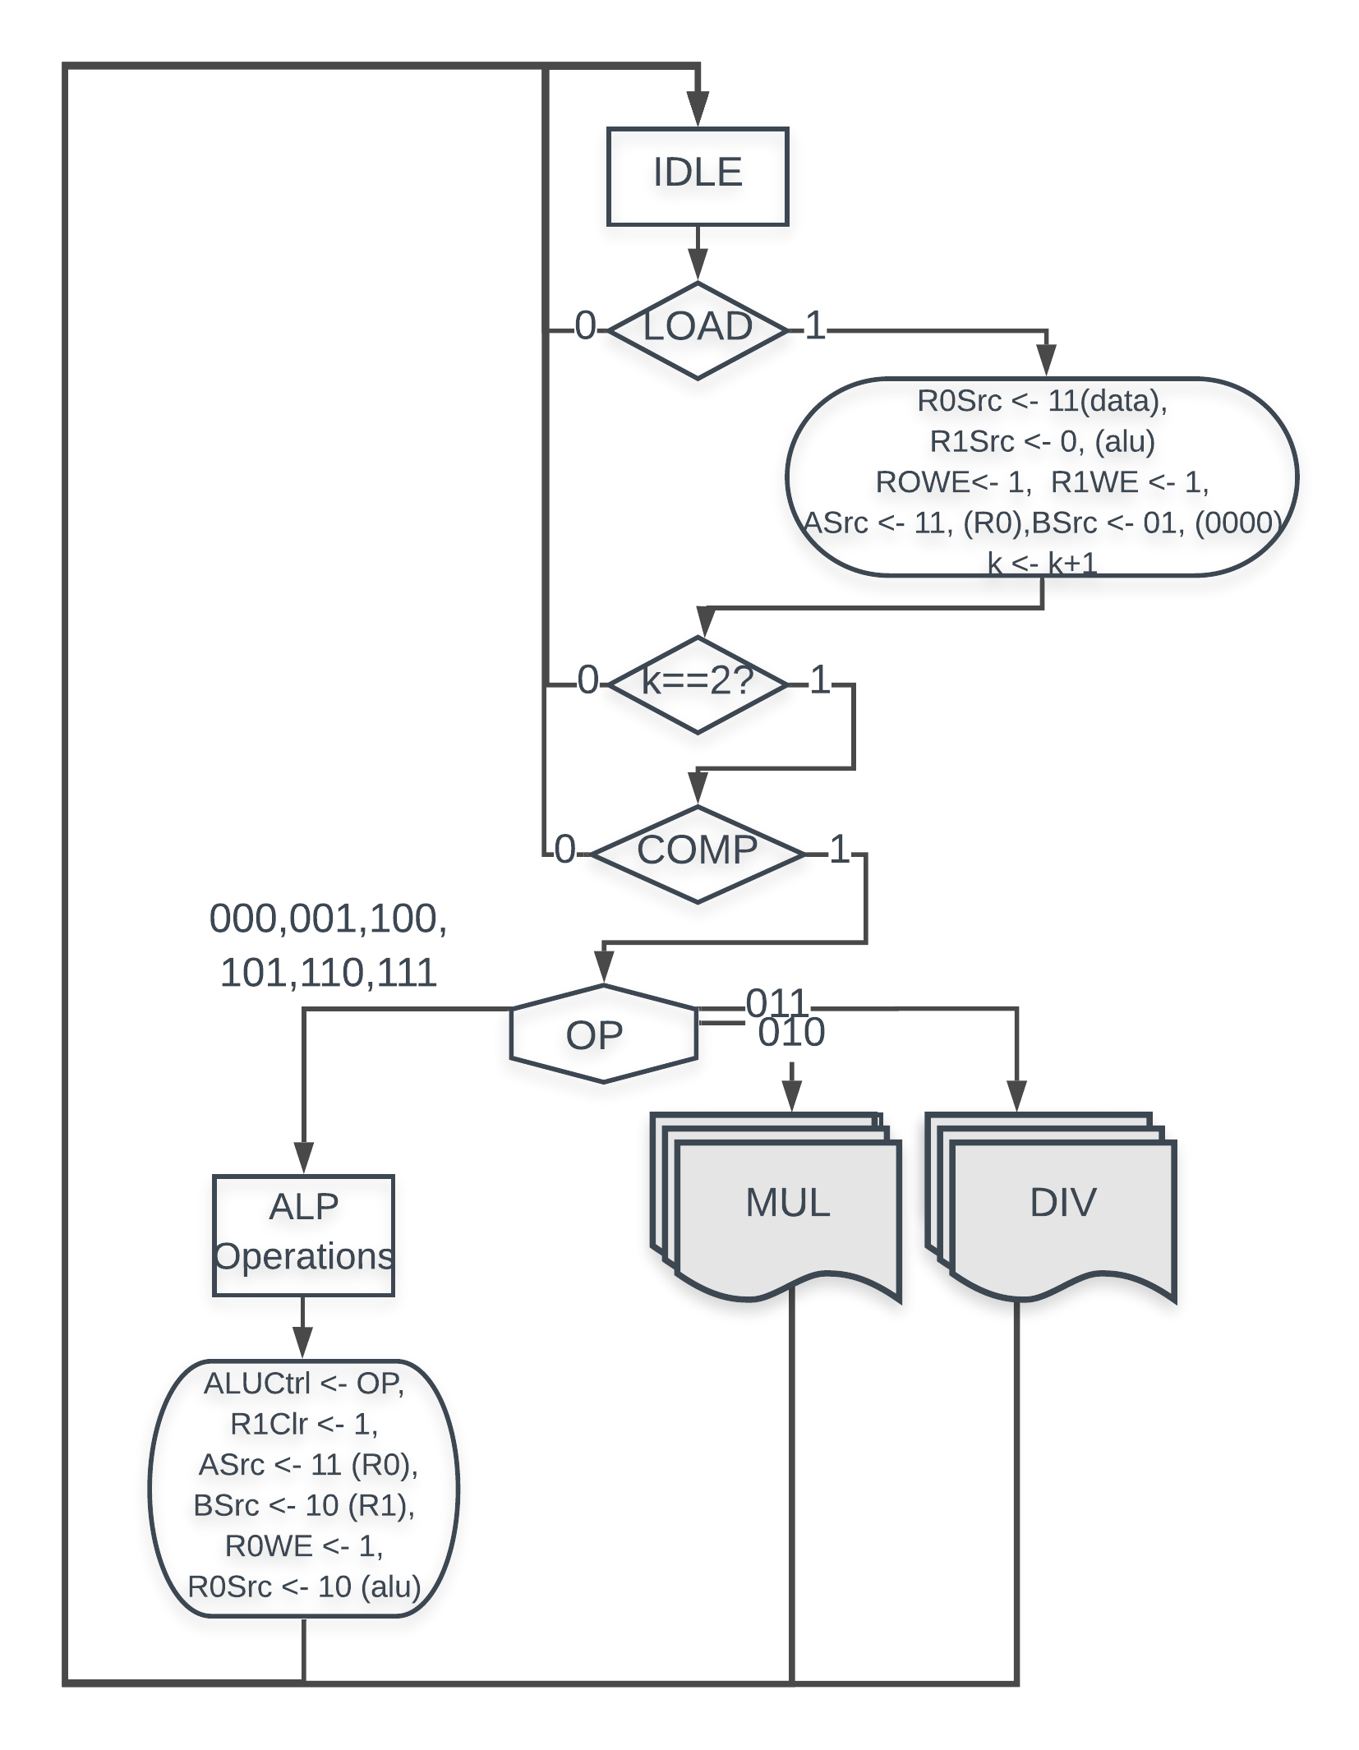

Figure 5. ASM Chart of the second black box connected to the first one

4.

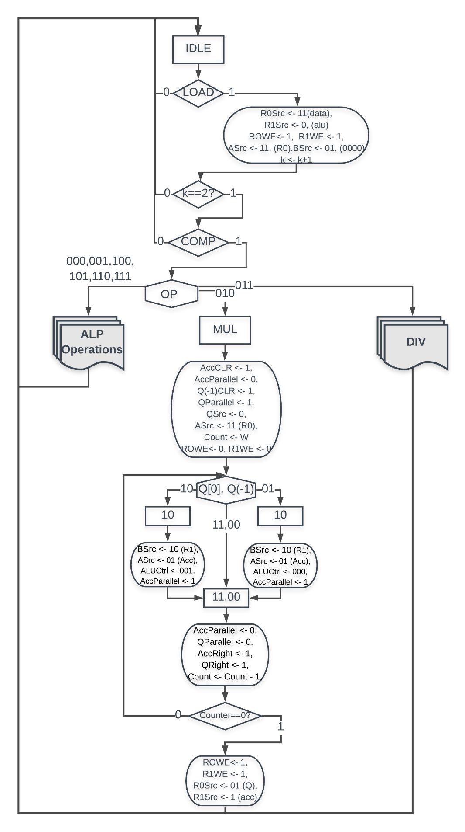

Figure 6. ASM Chart of the multiplication algorithm

Since we are using Booth’s algorithm in our multiplication algorithm, it is both compatible wtih both signed and unsigned numbers.

5.

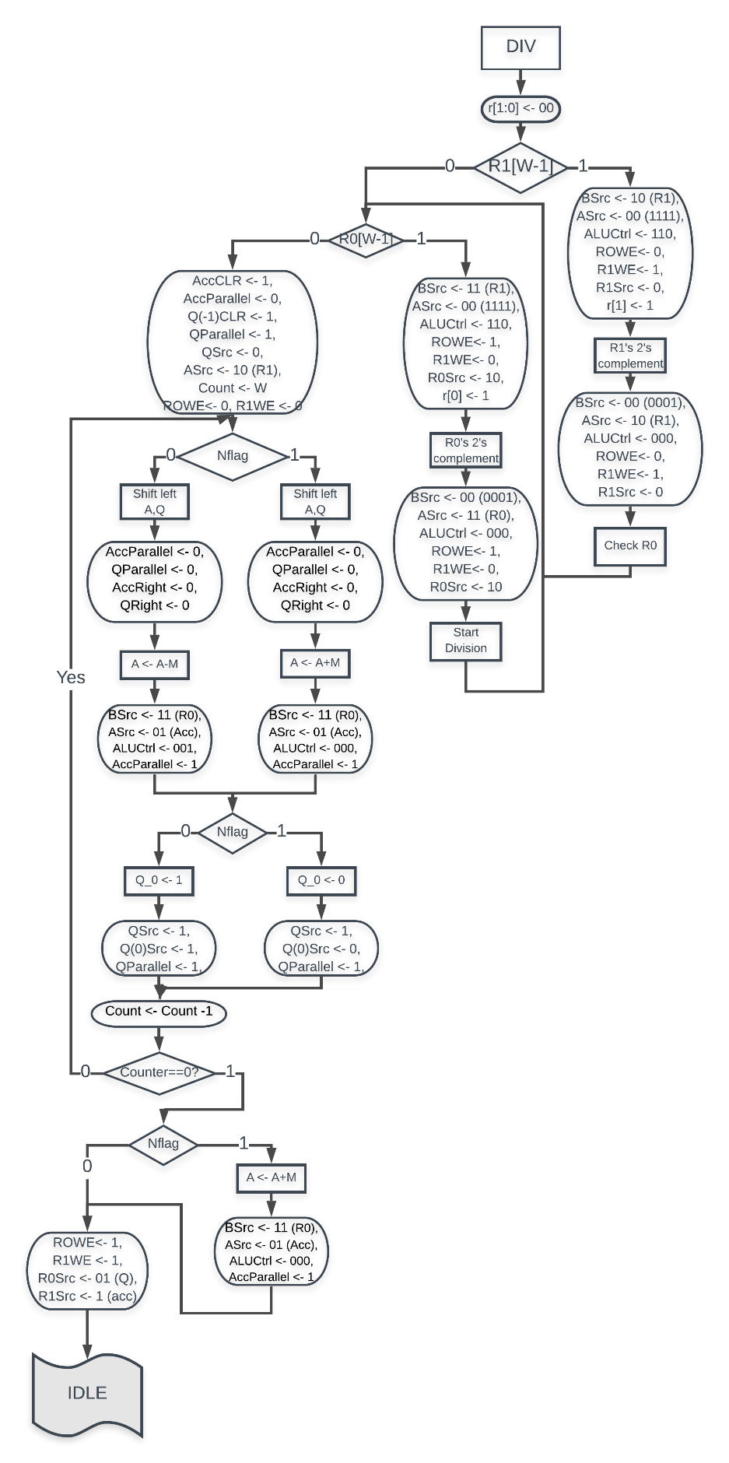

Figure 7. ASM Chart of the division algorithm

Since we check the operands and updates the quotient and remainder signes, we are able to use signed numbers for our multiplication controller.

**6**. For logic and arithmetic operations except the multiplication and division, they take 4 cycles to finish the the operation.

Multiplication algorithm takes 16 cycles to complete.

Division algorithm takes 24 cycles at worst case.

**7.** My ASM chart has 22 states. I am using the Op signal as input directly to the ALU Unit. Therefore there is no need for additional datapath objects to connect the OP with ALUCtrl.